17
#include <stdio.h>

int main() {
int key[16], i;
printf("Enter 16 keys:\n");
for(i=0;i<16;i++) scanf("%d",&key[i]);

printf("Keys used for decryption:\n");
for(i=15;i>=0;i--)
printf("K%d = %d\n", i+1, key[i]);

return 0;
}
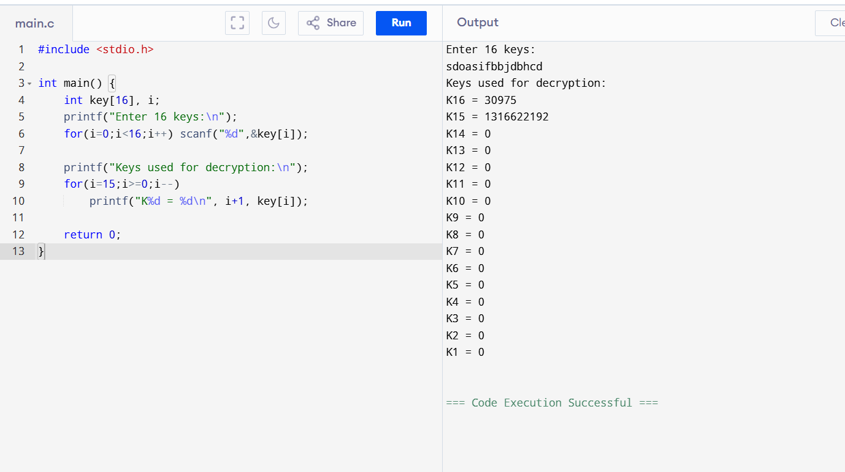
18
#include <stdio.h>

int main() {
int key[56], i;
printf("Enter 56-bit key:\n");
for(i=0;i<56;i++) scanf("%d",&key[i]);

printf("First 28 bits:\n");
for(i=0;i<28;i++) printf("%d", key[i]);

printf("\nLast 28 bits:\n");
for(i=28;i<56;i++) printf("%d", key[i]);

return 0;
}
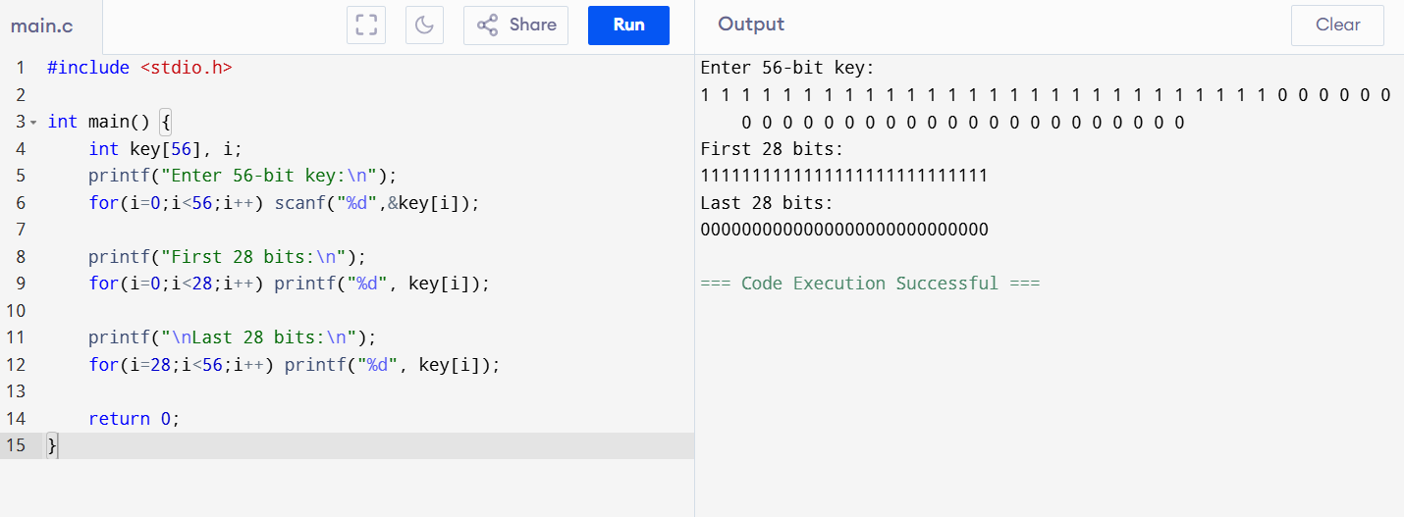
19
#include <stdio.h>

int main() {
int p, k, iv;
printf("Plaintext Key IV: ");
scanf("%d%d%d",&p,&k,&iv);

int c = (p ^ iv) ^ k;
printf("Cipher = %d", c);

return 0;
}
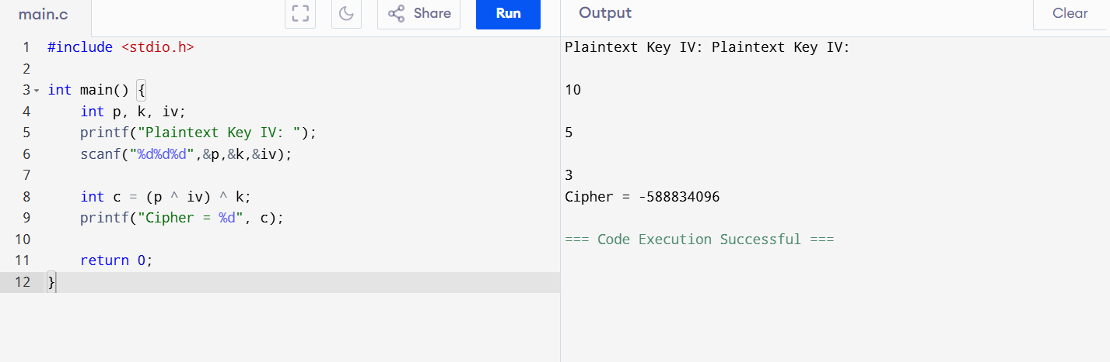
20
#include <stdio.h>

int main() {
int p, k;
printf("Plaintext Key: ");
scanf("%d%d",&p,&k);

printf("Cipher = %d", p ^ k);
return 0;
}
